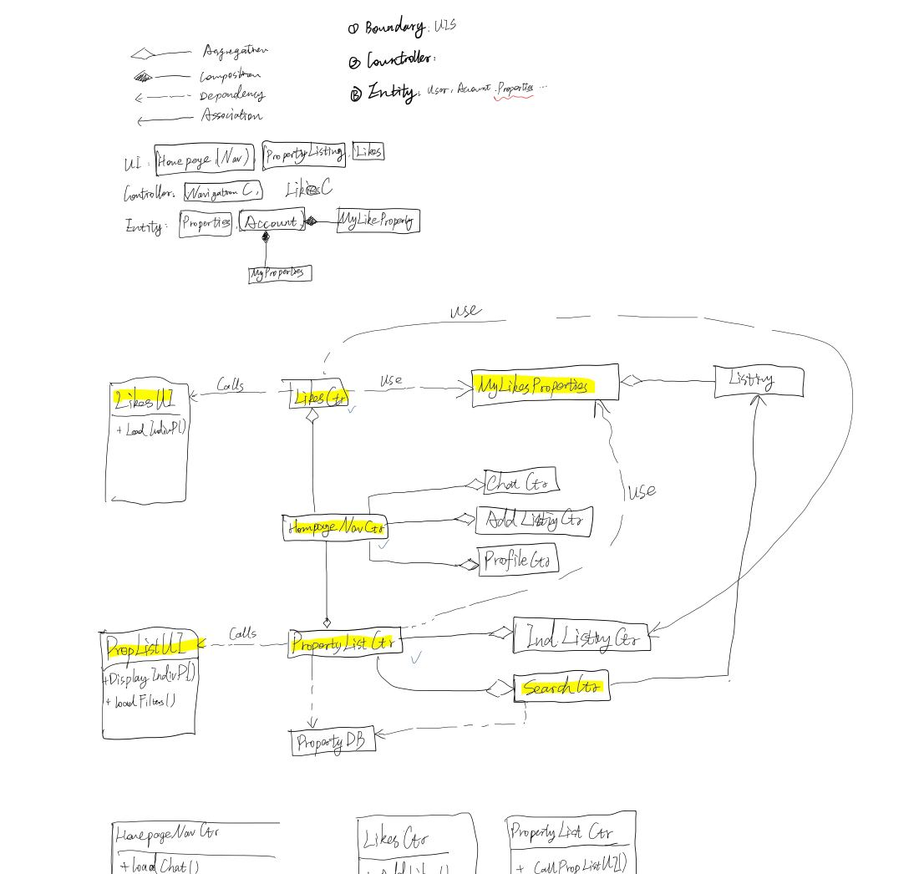

Next Meeting: Next Tue 9.30pm

DELIVERABLES:

1. Complete use case diagram (Done)

2. Use case descriptions (Wei Hao finish the “Compare”)

3. Class diagram of entity classes (ALL add in their parts then Wei Hao, Yupei, Jabez link and touch up)

4. Key boundary classes and control classes (pending any changes)

5. Sequence diagrams of some use cases (Bryan and Glendon)

6. Initial Dialog map (Done)